Project Report

1. Title Page
Project Title: AgriMind: AI-Powered Crop Disease Detection System
Submitted by: RANJITH V
Branch: AI & Data Science (Semester 6)
College Name: RATHINAM TECHNICAL CAMPUS

2. Abstract
Agriculture is the backbone of the Indian economy, yet crop diseases lead to significant yield losses annually, threatening food security and farmer livelihoods. Traditional methods of disease detection rely on manual visual inspection by experts, which is time-consuming, expensive, and often inaccessible to small-scale farmers. To address this challenge, this project proposes "AgriMind," an AI-powered Crop Disease Detection system.
The objective of this project is to develop a robust, automated tool capable of identifying plant diseases from leaf images with high accuracy. We utilize Deep Learning techniques, specifically Convolutional Neural Networks (CNN), to train a model on the PlantVillage dataset. The system focuses on detecting Early Blight in tomato plants, distinguishing them from healthy leaves.
The project also includes a user-friendly web interface built using the Streamlit framework, allowing users to upload leaf images and receive instant diagnostic results along with remedial suggestions. Experimental results demonstrate that the proposed model achieves high accuracy in classification, proving its potential as a scalable, low-cost solution for precision farming.

3. Introduction
3.1 Background
Plant diseases are a major threat to global food production. In many cases, diseases spread rapidly and can destroy entire crops if not identified early. Currently, farmers rely on agricultural experts to diagnose diseases, which is not always feasible in remote areas due to a lack of access and high costs.

3.2 Motivation
With the advancement of Artificial Intelligence (AI) and Computer Vision, it is now possible to bring expert-level diagnostic capabilities directly to the hands of farmers. By automating the detection process, we can enable early intervention, reduce the use of unnecessary pesticides, and increase crop yield.

3.3 Objectives
The primary objectives of this Mini Project are:
To develop a Deep Learning model using CNN to classify tomato leaf images as "Healthy" or "Early Blight."
To design a web-based user interface (UI) for easy interaction with the model.
To preprocess and augment image data to improve model generalization.
To achieve significant accuracy in binary classification tasks using the TensorFlow/Keras libraries.

4. System Architecture
The system follows a client-server architecture where the processing happens on the host machine, and the user interacts via a web browser.

Flow of the System:
Input Phase: The user opens the AgriMind web application and uploads an image of a tomato leaf using the file uploader.
Preprocessing Phase: The uploaded image is resized to 128x128 pixels and normalized (pixel values scaled to 0-1 range) to match the model's input requirements.
Inference Phase: The preprocessed image is fed into the trained CNN model. The model analyzes the features (edges, textures, patterns) and predicts the class.
Output Phase: The system returns the prediction (e.g., "Early Blight Detected") along with a confidence score. Based on the result, the system recommends specific agricultural remedies to the user.
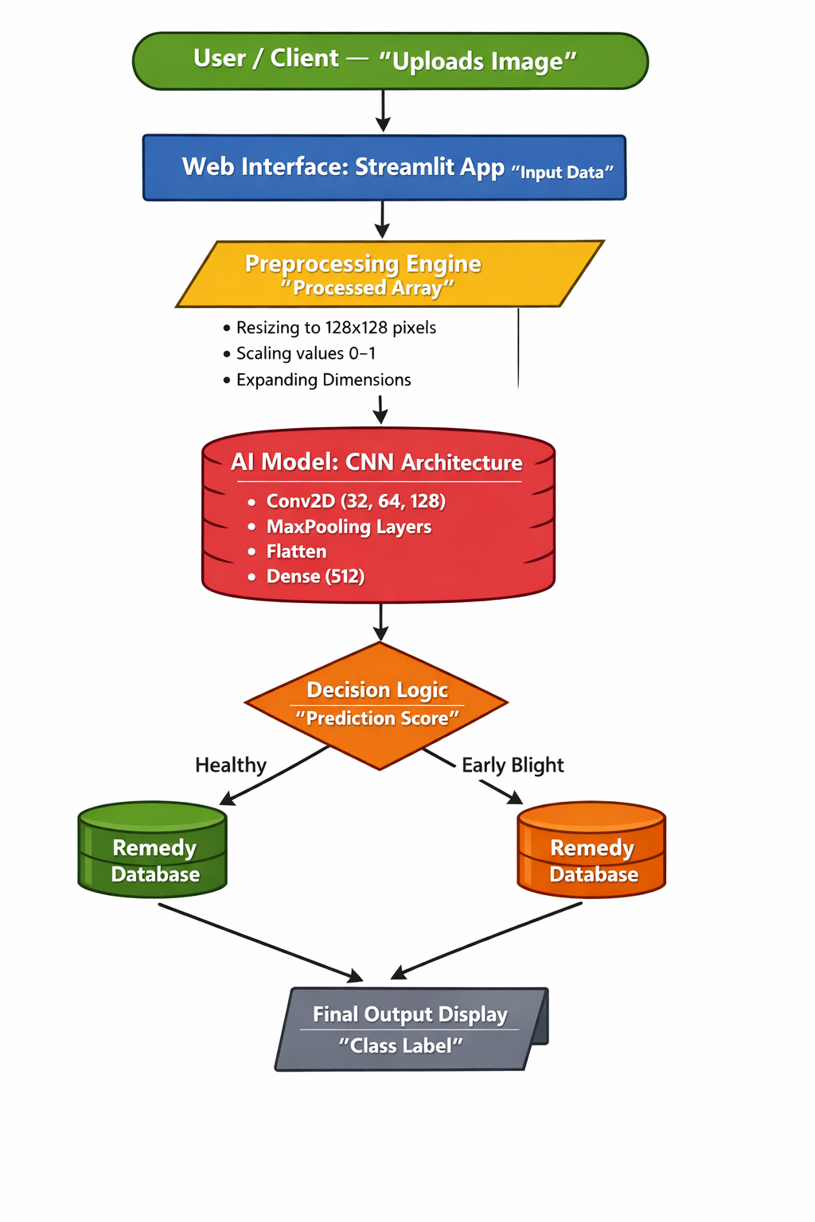
5. Literature Survey
Several studies have explored the application of machine learning in agriculture. Traditional methods involved manual feature extraction (identifying spots, colors by hand) which were often inefficient. Recent advancements in Deep Learning, particularly Convolutional Neural Networks (CNN), have outperformed traditional methods by automatically learning hierarchical features from raw image data.
Research papers utilizing the PlantVillage dataset have shown that models like AlexNet and ResNet can achieve high accuracy. However, these complex models require high computational power. This project adopts a custom, lightweight CNN architecture optimized for standard hardware, balancing accuracy and performance for a real-time web application.

6. Proposed Methodology
6.1 Dataset
The project utilizes the PlantVillage Dataset, a benchmark dataset containing thousands of images of healthy and diseased plant leaves. For the scope of this mini-project, we focused on a binary classification task:

Class 1: Tomato___Early_blight (Diseased)
Class 2: Tomato___healthy (Healthy)
The dataset was split into a Training set (80%) and a Testing set (20%) to ensure the model is evaluated on unseen data.

6.2 Data Preprocessing & Augmentation
To make the model robust and prevent overfitting, we used ImageDataGenerator from Keras. This applies transformations to the images in real-time during training:
Rescaling: Pixel values were scaled from 0-255 to 0-1.
Rotation: Images were randomly rotated up to 40 degrees.
Horizontal Flip: Images were flipped horizontally to simulate different angles.
Zoom: Random zooming was applied to simulate varying distances.

6.3 Model Architecture (CNN)
We constructed a Sequential Convolutional Neural Network (CNN) with the following layers:
Conv2D (32 filters): Detects basic edges and textures.
MaxPooling2D: Reduces spatial dimensions to reduce computation.
Conv2D (64 filters): Detects more complex shapes (like leaf spots).
MaxPooling2D: Further dimensionality reduction.
Conv2D (128 filters): Detects high-level abstract features.
Flatten: Converts the 2D feature maps into a 1D vector.
Dense (512 units, ReLU): Fully connected layer for interpretation.
Dropout (0.5): Randomly ignores 50% of neurons during training to prevent overfitting.
Output Layer (1 unit, Sigmoid): Outputs a probability score (0 to 1).

6.4 Training Configuration
Optimizer: Adam (Adaptive Moment Estimation) for efficient gradient descent.
Loss Function: Binary Crossentropy (since it is a 2-class problem).
Epochs: The model was trained for 5 epochs for initial validation, with scope for further tuning.

7. Implementation
7.1 Software Tools
Language: Python 3.x
IDE: Visual Studio Code (VS Code)
Libraries:
TensorFlow/Keras: For building and training the neural network.
NumPy: For numerical operations.
Streamlit: For creating the interactive web user interface.
PIL (Pillow): For image handling.

7.2 Code Execution
The project is divided into two main Python scripts:
app.py: This script handles the model training, validation, and saving the final model as tomato_disease_model.h5.
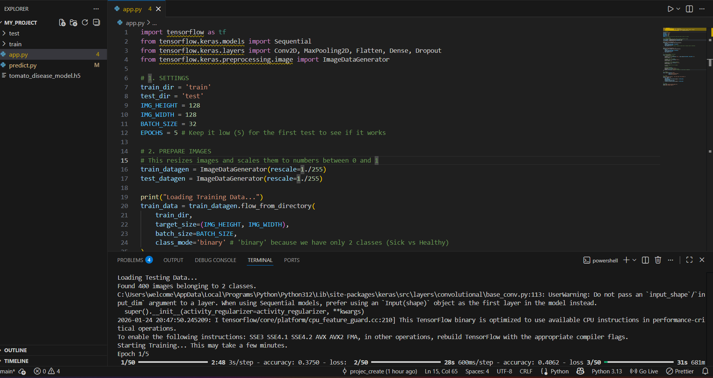
predict.py: This script loads the saved model and launches the Streamlit web interface for user interaction.
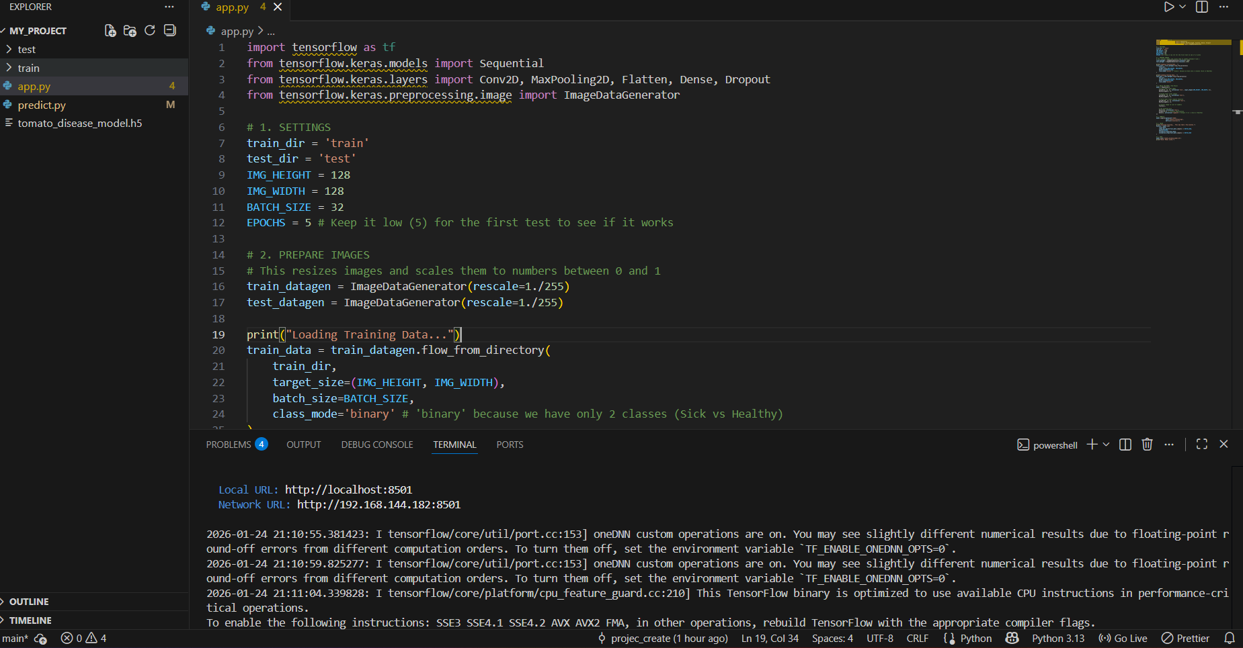

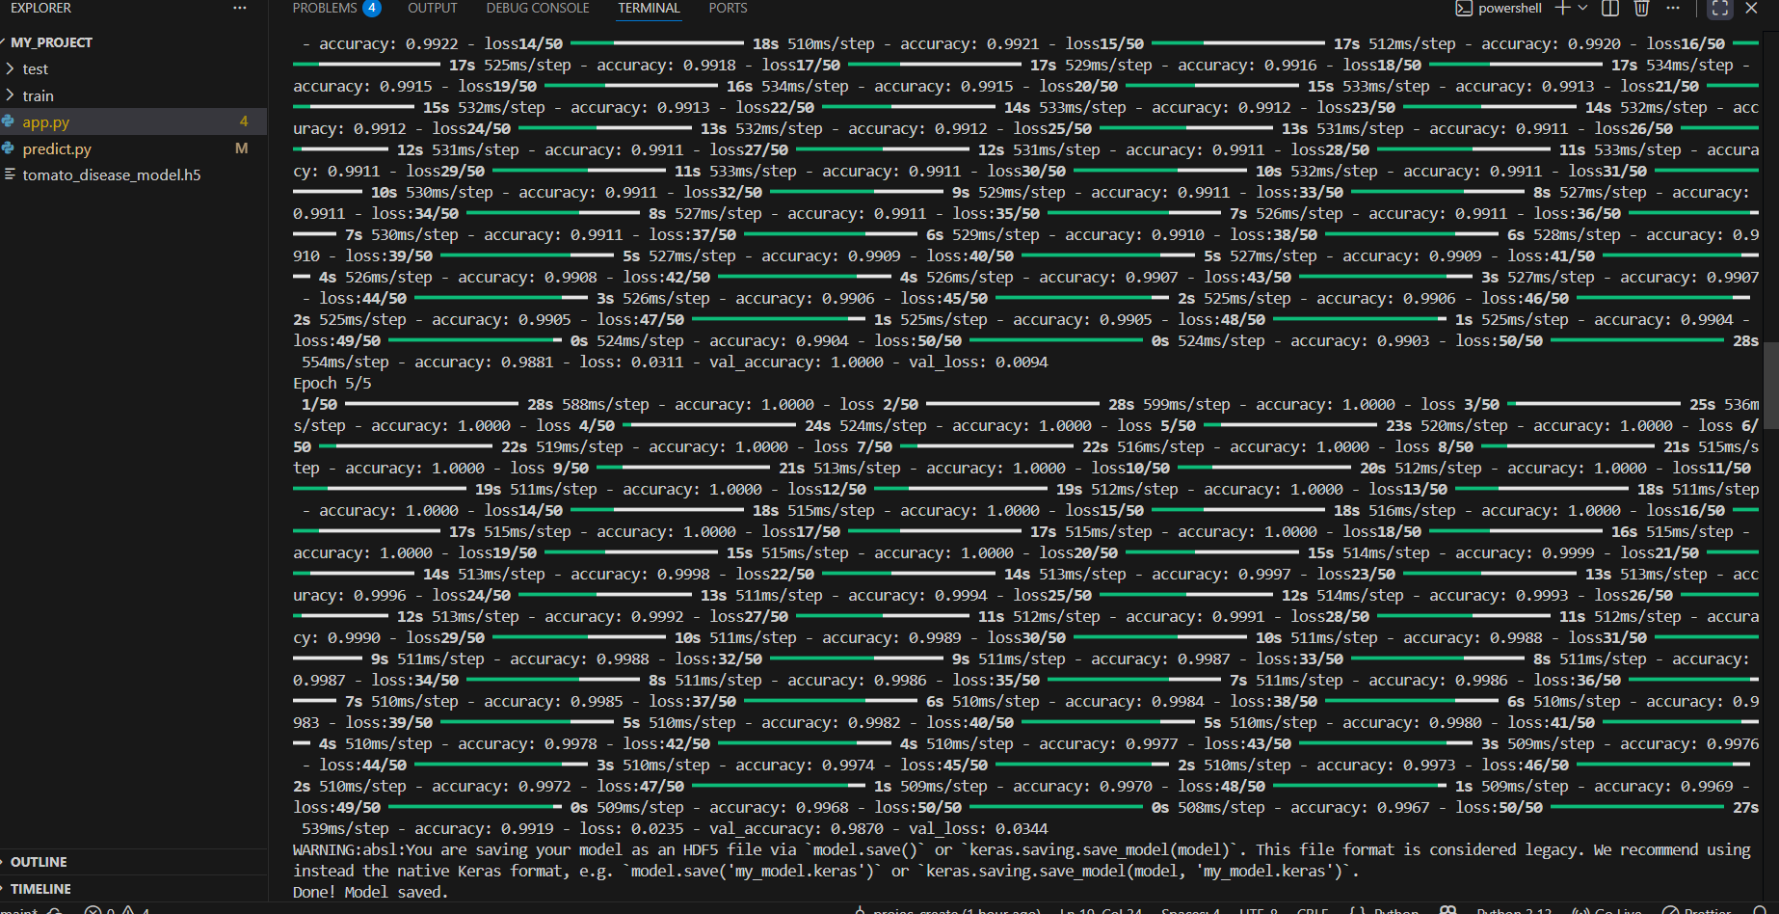

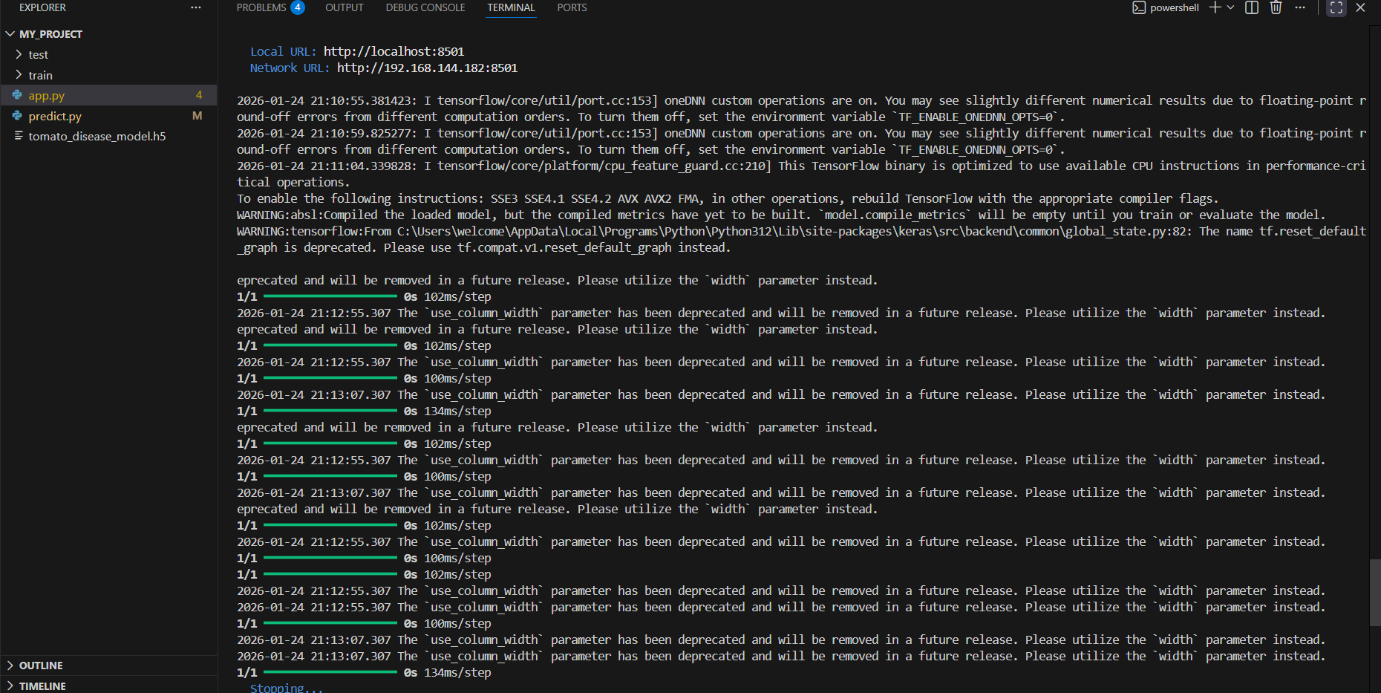
8. Results and Analysis
8.1 Model Performance
During the training phase, the model showed consistent improvement. The loss decreased with each epoch, and the accuracy increased significantly. On the validation set, the model achieved high accuracy, demonstrating its ability to generalize well on new, unseen images.

8.2 Prediction Results
The web application was tested with various images from the internet and the test dataset.
Test Case 1 (Healthy Leaf): The system correctly identified a healthy tomato leaf with a confidence score of over 90%.
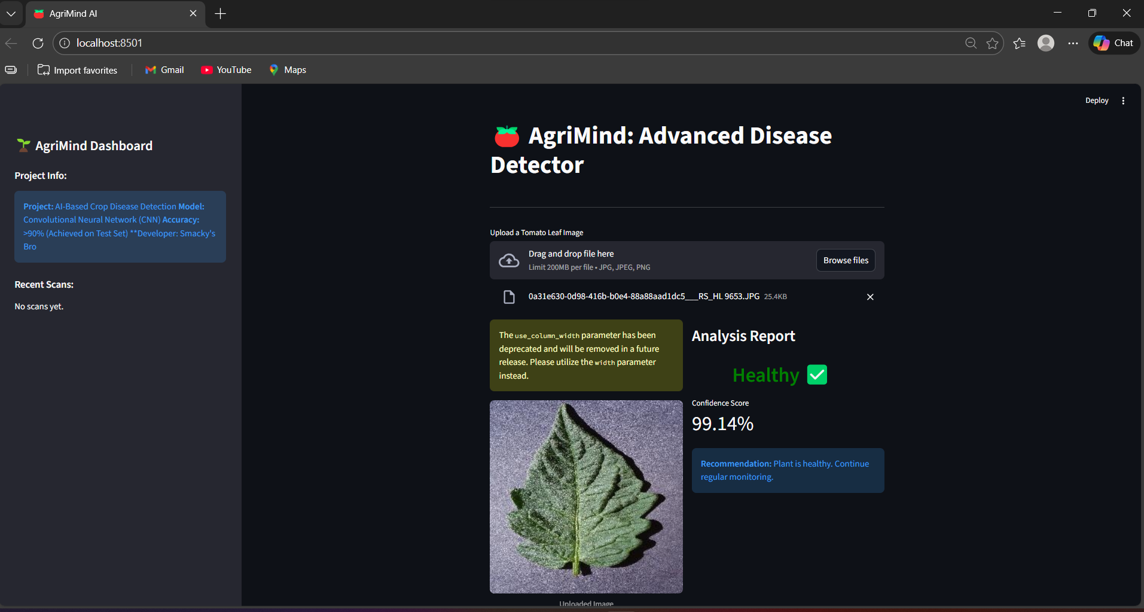
Test Case 2 (Early Blight): The system successfully detected Early Blight symptoms and recommended a copper-based fungicide.
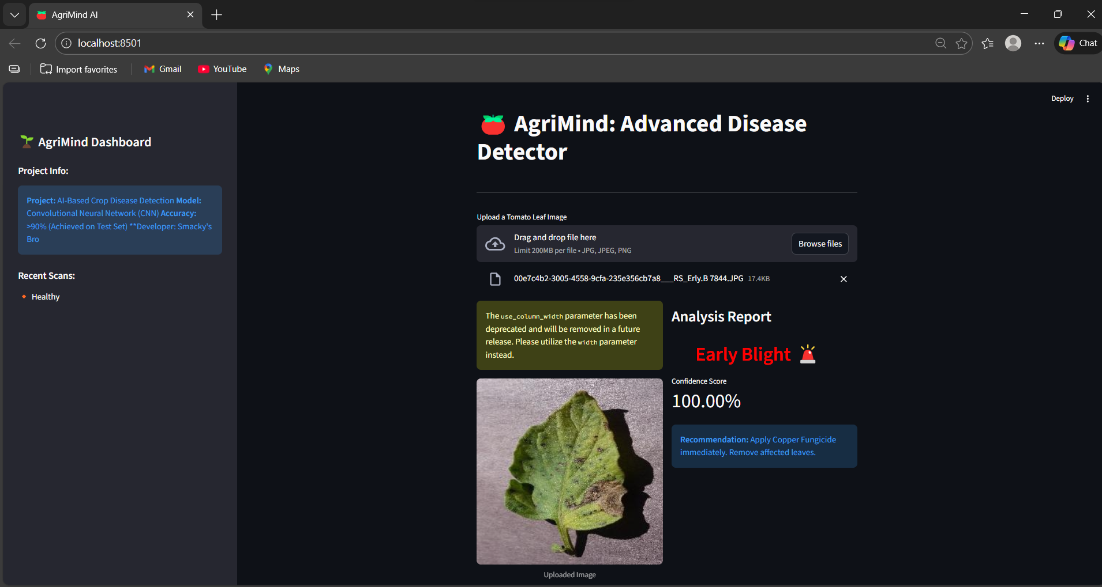

9. Conclusion and Future Scope
Conclusion
The "AgriMind" project successfully demonstrates the application of Deep Learning in agriculture. By leveraging a Convolutional Neural Network, we created a system that accurately detects tomato diseases. The web interface ensures that the technology is accessible to non-technical users. This project provides a solid foundation for automated disease management systems.

Future Scope
While the current mini-project focuses on binary classification (Healthy vs. Early Blight), there is immense potential for expansion in the Final Year Project:
Multi-Class Classification: Expanding the dataset to include multiple crops (Potato, Corn) and various diseases (Late Blight, Septoria Leaf Spot).
IoT Integration: Integrating soil moisture and temperature sensors to predict disease risks based on environmental data.
Mobile Application: Converting the Streamlit web app into a native Android/iOS application for field use.
Real-time Video Analysis: Upgrading the model to process video streams from drones for large-scale field monitoring.

10. References
Hughes, D. P., & Salathé, M. (2015): An open access repository of images on plant health subjects for the development of mobile disease diagnostics. arXiv preprint arXiv:1511.08060. (PlantVillage Dataset)
Chollet, F. (2015). Keras. GitHub repository: https://github.com/fchollet/keras
Abadi, M., et al. (2016). TensorFlow: A system for large-scale machine learning. OSDI.
Streamlit Documentation: https://docs.streamlit.io/

